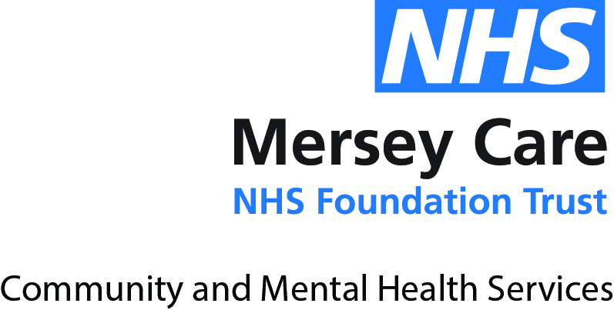

1 April 2021

v.fillis1995@gmail.com

Dear Ms Fillis

**FREEDOM OF INFORMATION REQUEST AND RESPONSE**

**REF: MCT/FOI/2021/5679**

Further to your Freedom of Information request in respect of adult mental health services broken down into accommodation status, please find a response from the Trust below.

Mersey Care NHS Foundation Trust provides adult specialist mental health, addiction, learning disability and community health services.

We provide specialist inpatient and community mental health, learning disabilities, addiction services and acquired brain injury services for the people of Liverpool, South Sefton, and Kirkby, Merseyside.

We serve more than 11 million people providing community physical health services in Liverpool and South Sefton, secure mental health services for the North West of England, the West Midlands and Wales and specialist learning disability services across Lancashire, Greater Manchester, Cheshire and Merseyside.

**1. The total number of people in contact with adult mental health services broken down into accommodation status codes such as tenant, owner occupier, care home, rough sleeper, etc.**

**Please use the accommodation status codes specified in M003010 (as seen in the Data Set Specification (Amd 43/2019) file).**

**Please could you provide the data in a monthly breakdown for the following years:-**

**01 January 2018 to 31 December 2018**

**01 January 2019 to 31 December 2019**

**01 January 2020 to 31 December 2020**

**01 January 2021 to latest available data**

Please see attached

**2. The total number of people in adult mental health services who are on a CPA broken down into accommodation status codes such as tenant, owner occupier, care home, rough sleeper, etc.**

Please see attached

**3. The total number of people in adult mental health services who are on Section 117 Aftercare broken down into accommodation status codes such as tenant, owner occupier, care home, rough sleeper, etc.**

Please see attached

If you are unhappy with the way your request for information has been handled, you can request a review by writing to:

Jeanie Hedley,

Head of Information Governance and Data Protection Officer,

Mersey Care NHS Foundation Trust and North West Boroughs Healthcare NHS Foundation Trust

V7, Kings Business Park

Prescot

L34 1PJ

Email: freedomofinformation@merseycare.nhs.uk

If you remain dissatisfied with the handling of your request or complaint, you have a right to appeal to the Information Commissioner at:

The Information Commissioner's Office,

Wycliffe House, Water Lane, Wilmslow,

Cheshire, SK9 5AF.

Telephone: 0303 123 1113 Website: [www.ICO.org.uk](http://www.ICO.org.uk)

There is no charge for making an appeal.

**Please Note**: Under the Privacy and Electronic Communications (EC Directive) Regulations 2003, Mersey Care NHS Foundation Trust asks not to receive unsolicited marketing communications.

Thank you for your interest in Mersey Care NHS Foundation Trust.

Yours sincerely

**FREEDOM OF INFORMATION TEAM**